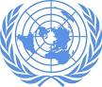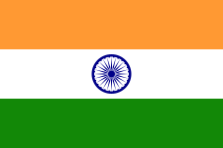

Workshop, under the Auspices of the United Nations, in Support of the Regular Process on Global Reporting and Assessment of the Marine Environment, including Socioeconomic Aspects
Chennai, India
27-28 JANUARY 2014

Annexes to the Report

Annex I – Modified Agenda
Annex II – List of Participants
Annex III
Annex IV
Annex V
Annex VI
Annex VII
Annex VIII
Annex IX

